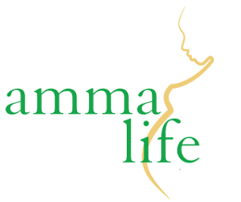

**Content Volunteer**

**Role**

Ammalife is a specialist, research driven organisation that is committed to tackling obstacles to good maternal healthcare in some of the world's poorest countries. Over the past decade, Ammalife has contributed to innovative and ground-breaking research in the field of maternal health. We are now seeking to make this research more accessible to the non-academic and non-medical community in order to promote greater awareness of issues of maternal health to the general public.

We are seeking a content volunteer who will be able to go through our past publications, synthesise our research and write summaries for each publication that are accessible to a non-technical audience. As well as helping to make our research more accessible, you will also aid in the production of new blogs on maternal health in the developing world, in order to raise awareness of these issues to people of a non-academic and non-medical background.

**Skills and Experience**

You will be a medical student or an early career qualified doctor who has an interest in maternal health and/or healthcare in the developing world. You will have a sound knowledge of gynaecology and obstetrics. You will have good writing skills and have the ability to write for a mixture of audiences. You will have the ability to understand academic and technical writing and make it accessible to a non-academic and non-medical audience. You will have a good command of written English (being a native speaker of English is not a requirement for this role). You will be required to commit to at least four hours per week for at least a six-month basis.

**What will I gain from this role?**

Whilst this position is voluntary, you will have the opportunity to gain experience in the charity sector, and to develop transferable writing and editing skills. You will also be contributing towards our vital work working to improve healthcare outcomes of mothers in some of the poorest areas of the world.

**Application process**

Please send a CV and a brief motivational statement to [info@ammalife.org](mailto:info@ammalife.org) by **Friday 15th February**. Please note this is an unpaid voluntary role.